**Industrial Internship Report on**

**Student Portal**

**Prepared by**

**Aniket Satish Elinje**

|  |
| --- |
| *Executive Summary* |
| This report provides details of the Industrial Internship provided by upskill Campus and The IoT Academy in collaboration with Industrial Partner UniConverge Technologies Pvt Ltd (UCT).  This internship was focused on a project/problem statement provided by UCT. We had to finish the project including the report in 6 weeks’ time.  My project was **Student Portal**  This internship gave me a very good opportunity to get exposure to Industrial problems and design/implement solution for that. It was an overall great experience to have this internship. |

**TABLE OF CONTENTS**

1 Preface 3

2 Introduction 4

2.1 About UniConverge Technologies Pvt Ltd 4

2.2 About upskill Campus 8

2.3 Objective 9

2.4 Reference 9

2.5 Glossary 10

3 Problem Statement 11

4 Existing and Proposed solution 12

5 Proposed Design/ Model 13

5.1 High Level Diagram (if applicable) 13

5.2 Low Level Diagram (if applicable) 13

5.3 Interfaces (if applicable) 13

6 Performance Test 14

6.1 Test Plan/ Test Cases 14

6.2 Test Procedure 14

6.3 Performance Outcome 14

7 My learnings 15

8 Future work scope 16

# Preface

Summary of the whole 6 weeks’ work.

About need of relevant Internship in career development.

Brief about Your project/problem statement.

Opportunity given by USC/UCT.

How Program was planned

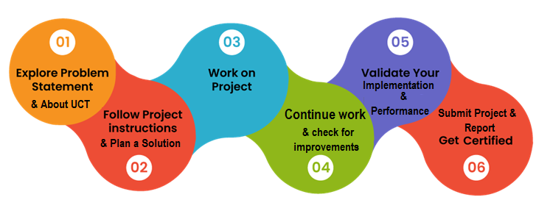

Your Learnings and overall experience.

Thank to all (with names), who have helped you directly or indirectly.

Your message to your juniors and peers.

# Introduction

## About UniConverge Technologies Pvt Ltd

A company established in 2013 and working in Digital Transformation domain and providing Industrial solutions with prime focus on sustainability and RoI.

For developing its products and solutions it is leveraging various**Cutting Edge Technologies e.g. Internet of Things (IoT), Cyber Security, Cloud computing (AWS, Azure), Machine Learning, Communication Technologies (4G/5G/LoRaWAN), Java Full Stack, Python, Front end**etc.



1. UCT IoT Platform **(****)**

**UCT Insight** is an IOT platform designed for quick deployment of IOT applications on the same time providing valuable “insight” for your process/business. It has been built in Java for backend and ReactJS for Front end. It has support for MySQL and various NoSql Databases.

* It enables device connectivity via industry standard IoT protocols - MQTT, CoAP, HTTP, Modbus TCP, OPC UA
* It supports both cloud and on-premises deployments.

It has features to  
• Build Your own dashboard  
• Analytics and Reporting  
• Alert and Notification  
• Integration with third party application(Power BI, SAP, ERP)  
• Rule Engine

 

1. **Smart Factory Platform (****)**

Factory watch is a platform for smart factory needs.

It provides Users/ Factory

* with a scalable solution for their Production and asset monitoring
* OEE and predictive maintenance solution scaling up to digital twin for your assets.
* to unleased the true potential of the data that their machines are generating and helps to identify the KPIs and also improve them.
* A modular architecture that allows users to choose the service that they what to start and then can scale to more complex solutions as per their demands.

Its unique SaaS model helps users to save time, cost and money.

 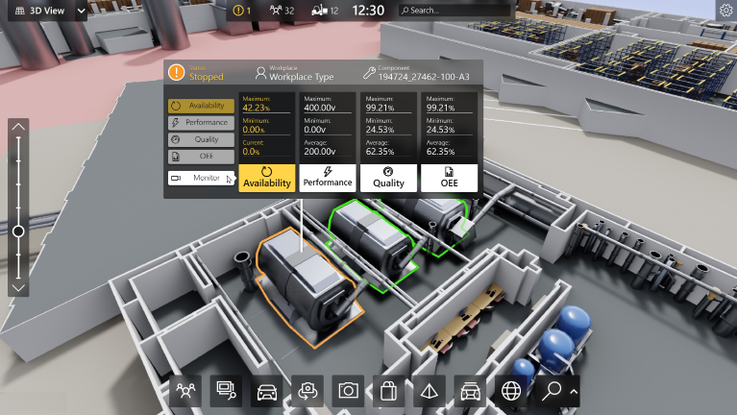

1. 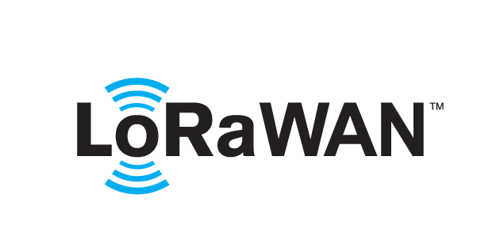 based Solution

UCT is one of the early adopters of LoRAWAN teschnology and providing solution in Agritech, Smart cities, Industrial Monitoring, Smart Street Light, Smart Water/ Gas/ Electricity metering solutions etc.

1. Predictive Maintenance

UCT is providing Industrial Machine health monitoring and Predictive maintenance solution leveraging Embedded system, Industrial IoT and Machine Learning Technologies by finding Remaining useful life time of various Machines used in production process.



## About upskill Campus (USC)

upskill Campus along with The IoT Academy and in association with Uniconverge technologies has facilitated the smooth execution of the complete internship process.

USC is a career development platform that delivers **personalized executive coaching** in a more affordable, scalable and measurable way.



Seeing need of upskilling in self paced manner along-with additional support services e.g. Internship, projects, interaction with Industry experts, Career growth Services

<https://www.upskillcampus.com/>

upSkill Campus aiming to upskill 1 million learners in next 5 year

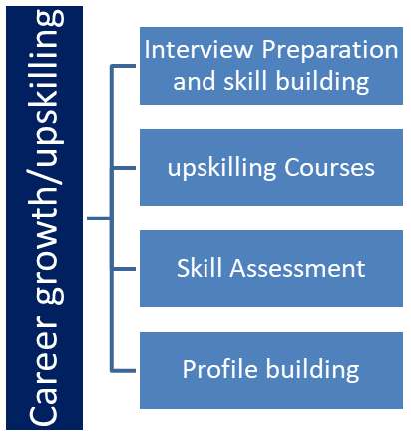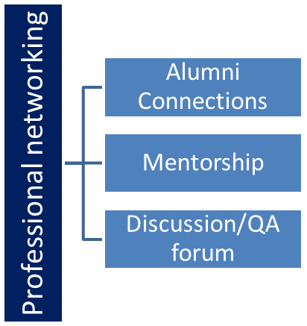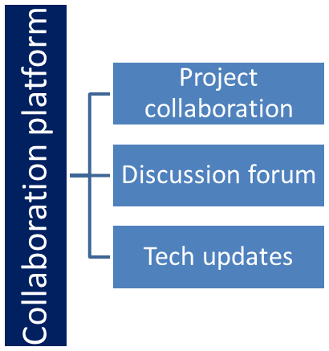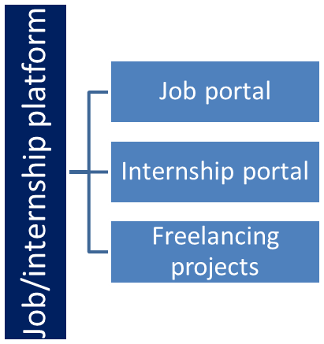

## The IoT Academy

The IoT academy is EdTech Division of UCT that is running long executive certification programs in collaboration with EICT Academy, IITK, IITR and IITG in multiple domains.

## Objectives of this Internship program

The objective for this internship program was to

 ☛ get practical experience of working in the industry.

 ☛ to solve real world problems.

 ☛ to have improved job prospects.

 ☛ to have Improved understanding of our field and its applications.

 ☛ to have Personal growth like better communication and problem solving.

## Reference

[1]

[2]

[3]

## Glossary

|  |  |
| --- | --- |
| Terms | Acronym |
|  |  |
|  |  |
|  |  |
|  |  |
|  |  |

# Problem Statement

The development of the Student Industrial Internship Web Portal (SIIWP) aimed to automate existing manual business processes. By employing PHP 5, Easy PHP 2.0, Macromedia Dreamweaver MX 2004, MySQL Database, and Apache Web Server, the SIIWP facilitated various tasks such as internship eligibility verification, registration, student-lecturer pairing, visit scheduling, online logbook submission, monitoring, and grade book management for the industrial internship program at Universiti Teknologi PETRONAS. The development process followed a phased model, incorporating business process improvement techniques. The results indicated that the prototype effectively served as a communication platform for all stakeholders involved in the industrial internship program. It successfully streamlined the internship process and proved to be an invaluable tool for assisting in the management of the internship program.

# Existing and Proposed solution

To facilitate and monitor the students' internship process at UTP, the Student Industrial Internship Unit (SIIU) is responsible for handling various tasks. These tasks include student applications, eligibility checks, internship placement, lecturer visit scheduling, and grading. However, several problems arise due to the manual nature of these processes, leading to issues like missing data, redundancy, delays in the grading process, communication problems, and, most importantly, difficulties in student monitoring. Currently, communication within the SIIP is primarily conducted through telephone and email, which presents numerous challenges. For instance, updates must be disseminated individually to all students, incurring high communication costs and leading to inefficiencies. To enhance the SIIP's efficiency and address these challenges, it becomes imperative to explore digital solutions that can streamline the internship processes, improve communication channels, and optimize student monitoring. Implementing a robust web portal, like the previously mentioned Student Industrial Internship Web Portal (SIIWP), could be an effective way to automate manual tasks, ensure real-time data access, facilitate seamless communication, and ultimately improve the overall success of the internship program at UTP.

## Code submission (Github link)

https://github.com/Elinje/Student_Portal.git

## Report submission (Github link) :

https://github.com/Elinje/Student_Portal/blob/main/Project%20Report

# Proposed Design/ Model

Given more details about design flow of your solution. This is applicable for all domains. DS/ML Students can cover it after they have their algorithm implementation. There is always a start, intermediate stages and then final outcome.

# Performance Test

The current manual system used for the Student Industrial Internship Programme (SIIP) is facing various problems and pitfalls, leading to deficiencies in its overall functioning. Some of the key issues in the existing manual system include: Manual and time-consuming eligibility status identification: The process of checking and verifying students' eligibility status for the internship program requires manual cross-checking, leading to inefficiencies and delays. Manual student registration: Students are required to fill out paper forms for industrial internship registration. SIIU staff then manually enter the students' particulars and contact details into an Excel spreadsheet. This manual data entry process can lead to data errors due to human mistakes and is also time-consuming. Ineffective communication methods: Communication with the students is primarily conducted through telephone and email, which proves to be difficult and ineffective. This can lead to miscommunications and challenges in conveying important information to all students efficiently. Loss of important documents: The abundance of paperwork involved in the manual processes results in the loss of students' placement applications, resumes, and other crucial documents, leading to organizational challenges and potential setbacks for the internship program. Given these issues, it becomes evident that transitioning from the manual system to an automated and digital solution, such as the proposed Student Industrial Internship Web Portal (SIIWP), could significantly alleviate these problems. By automating eligibility checks, streamlining student registration processes, enabling efficient communication channels, and providing a secure and centralized digital repository for important documents, the SIIWP could enhance the overall efficiency, accuracy, and success of the SIIP at University Technology PETRONAS.

## Test Procedure

In order to ensure the system's reliability and eliminate faults, a fault removal strategy was implemented during each system version's development. This strategy encompasses a Validation and Verification (V&V) process, which involves thorough checks and analyses. It includes requirements reviews, design reviews, code inspections, and product testing. The testing process is summarized in Table 1. For the SIIWP System Version 3.0, acceptance testing was carried out, involving the participation of 30 users, including students, lecturers, and staff members. The primary goal of acceptance testing was to verify whether the system fulfills the functional and non-functional requirements established during the requirements determination phase. Additionally, it aimed to determine whether the system closely matches or precisely aligns with users' expectations. The acceptance testing phase is crucial to ensure that the system is ready for deployment and use by its intended users. By conducting rigorous testing and validation procedures, the developers can ensure that the system operates smoothly and meets the expectations of all stakeholders involved.

# Conclusion

The implementation of the Student Industrial Internship Web Portal (SIIWP) has been successful in meeting all functional and non-functional requirements. Since it was built based on the well-studied and improved SIIU business process, its core functionalities closely aligned with users' expectations. As a result, SIIWP effectively addressed the distant learning problem in the Student Industrial Internship Programme (SIIP), offering automation that improved business processes for SIIU in conducting the SIIP and providing high-quality service, thereby ensuring the success of the program. Additionally, SIIWP has the potential to become a central resource center for internships and job opportunities for UTP students. However, there are some limitations in the current version of SIIWP. These limitations include limited direct communication between users, potential data redundancy, and restricted accessibility from outside UTP. Users have also provided feedback and suggested additional functionalities that could enhance the SIIWP further. These suggestions are considered as areas for future work and possible enhancements to the system. Some of the future work and possible improvements for SIIWP include:Direct Communication Media: Implementing communication features like forums, blogs, and chat systems within SIIWP to enable direct communication between its users, fostering collaboration and knowledge sharing. Frequently Asked Questions (FAQ): Introducing a FAQ section to SIIWP, where users can share their knowledge and experiences gained during SIIP, storing them in the database, and mapping them to specific issues. This allows users to interact and seek answers to specific questions related to their internship experiences. Data Mining: Incorporating effective data mining techniques into SIIWP to provide users with a more desirable and insightful view of the database. This could help in discovering patterns, trends, and valuable insights related to internships and job opportunities. By addressing these limitations and considering the suggested enhancements, SIIWP can continue to evolve and offer an even more robust and comprehensive platform for managing the Student Industrial Internship Programme at Universiti Teknologi PETRONAS.